**Binomial Heaps**

**Concept**

* Binomial heaps are defined by binomial trees
* Binomial trees are defined recursively as:

1. A binomial tree of order 0 has only one node, the root node
2. A binomial tree of order I has a root node of I children, they are root nodes of binomial trees of ordered i-1, i-2,…,2,1,0

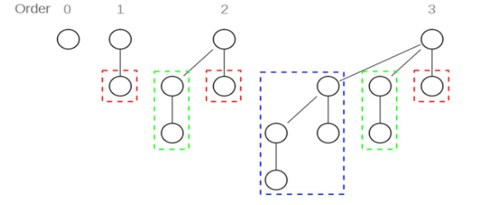

**Properties of Binomial Trees**

A binomial tree order I, denoted Bi, has properties:

1. Bi consists of two binomial trees Bi-1 linked together such that root of one is the leftmost child of the root of the other
2. Bi as 2i nodes
3. The height of Bi is i+1
4. The root of Bi has I children
5. There are C(I,h) node at level h (I choose h)

**Definition of Binomial Heaps**

* A binomial heap is a set of binomial trees with two properties:
  + Each binomial tree follows the min-heap property
  + There can be at most one binomial tree of any order

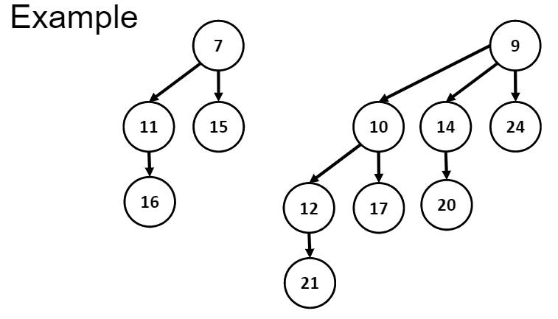

**Properties of Binomial Heaps**

1. The root of each binomial tree of a binomial heap contains the smallest key in the tree. The smallest key of the binomial heap is smallest key of roots.
2. A binomial heap of n nodes contains at most log n + 1 binomial trees

Consider the binary representation of n = dk … di … d1 d0. Each binomial tree corresponds to a none zero digit of representation. If the ith digit di (from 0th on the right side) di is 1, then it has a degree I binomial tree.

Example: if binomial heap has n = 5 nodes. Then 5=1012, then the binomial heap consists of binomial trees of degrees 0 and 2. (1 at the 2nd and 0th digit)

**Linked representation of binomial heaps**

* The node structure contains following fields:
  + A field key stores the key value
  + A field degree stores the degree of the node
  + A pointer p points to the parent of the node. If the node is the root node of a binomial tree, then p=NULL.
  + A pointer child points to the leftmost child of the node. If the node has no children, then child = NULL.
  + A pointer sibling points to the right sibling of the node. If the node is the rightmost child of its parent, then sibling = NULL.
* The roots binomial trees are stored in a linked list (called root list) in increasing order of degrees. Binomial heap are accessed by the head of the root list.
* The fields are used to store relation information for algorithms

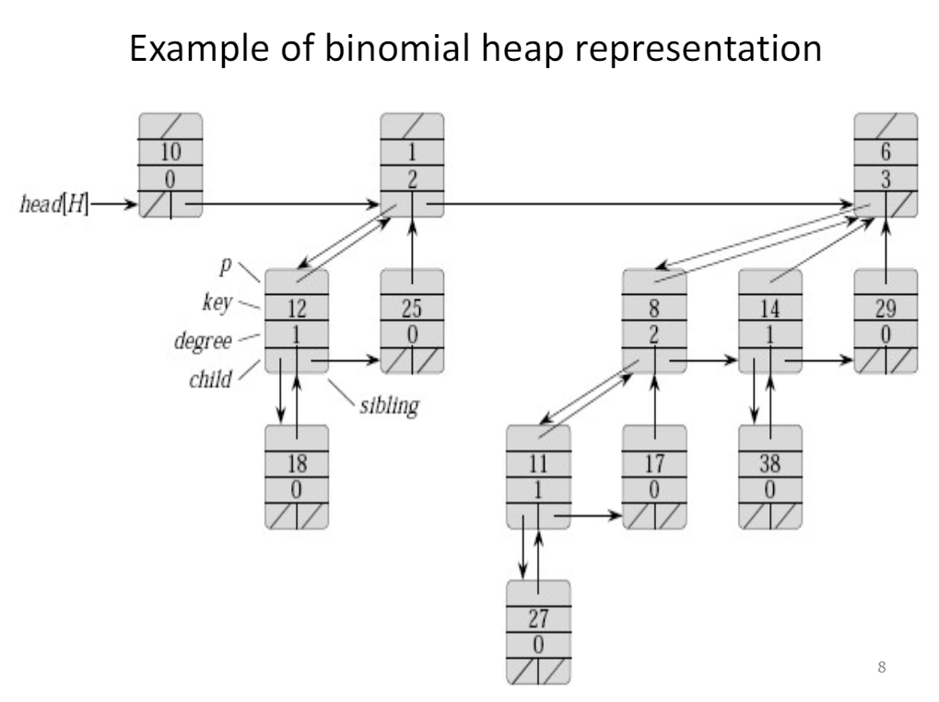

**Binomial heap operations**

1. Find-min

Algorithm: traverse the root list and return the pointer of the binomial tree root with the minimum key value

Since there are at most log n + 1 roots to check. Time : O(log n), Space: O(1)

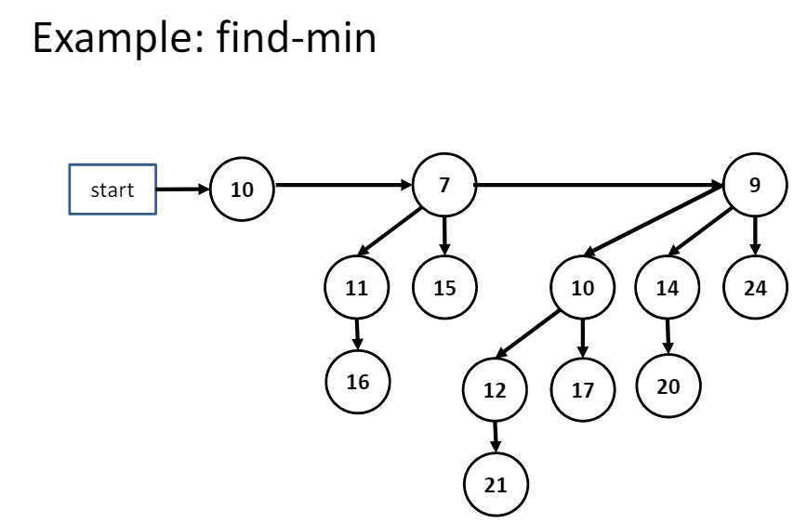

1. Unite two binomial heaps (union)

Algorithm: Given binomial heaps H1 and H2

Step 1: Merge root lists of H1 and H2 (as merging, sort by degree)

Step 2: restore binomial heap by linking binomial trees of the same degree together: traverse the root list, keep track of three pointers, prev, ptr, and next

If degrees of ptr and next are not same, move ahead

Else if key of ptr is smaller than or equal to key of next, then make next as a child of ptr by linking it with ptr, delete node of next from root list

Else if key of ptr is greater, then make ptr as child of next, delete node of ptr from root list

**Analysis of union operation**

Time complexity of union operation is O(log n)

If H1 contains n1 nodes and H2 contains n2 nodes, then H1 contains at most log (n1) + 1 roots and H2 contains at most log(n2) + 1 roots, H contains at most log (n2) + log (n1) + 2 <= 2 log(n) + 2 = )(log n)

Since n = n1+n2, H1 and H2 have at most log n roots and the merge takes O (log n) time.

Each iteration (the step 2) takes O(1) time. There are at most log(n1) + log (n2) + 2 iterations, the total time is thus O(log n)

Space complexity is O(1). Implemented by iterative algorithm using prev, ptr and next.

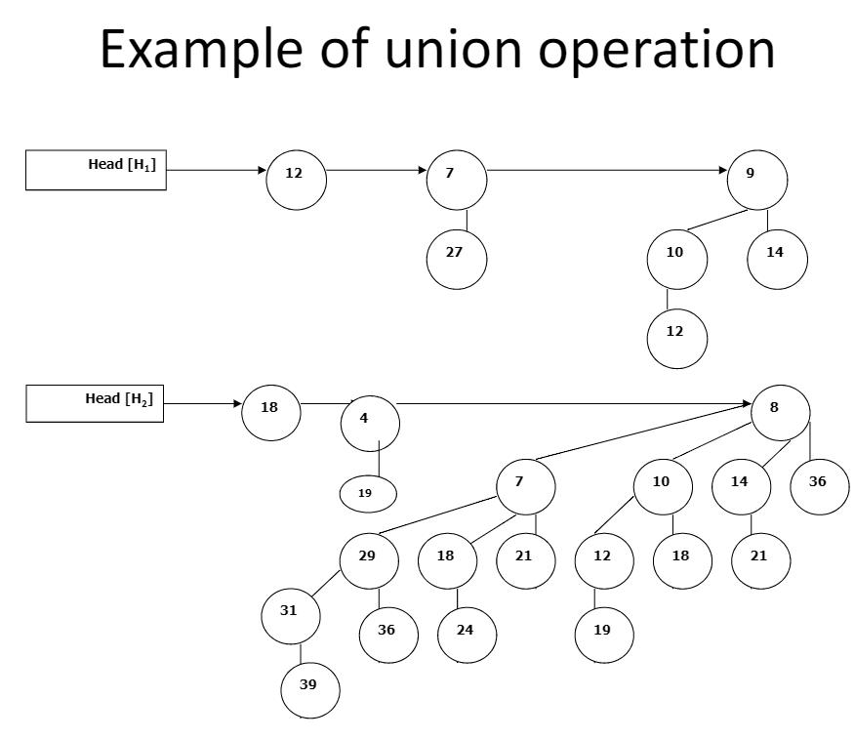

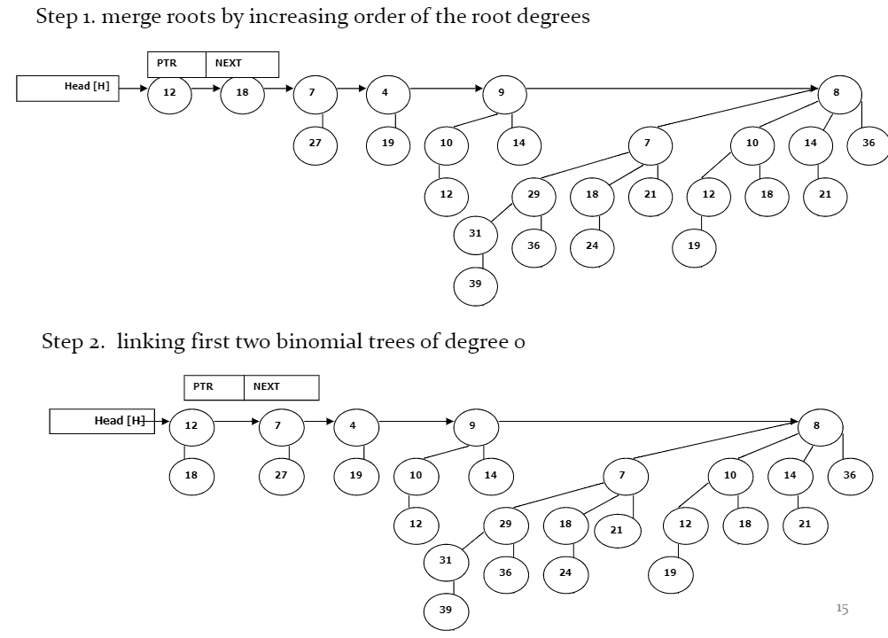

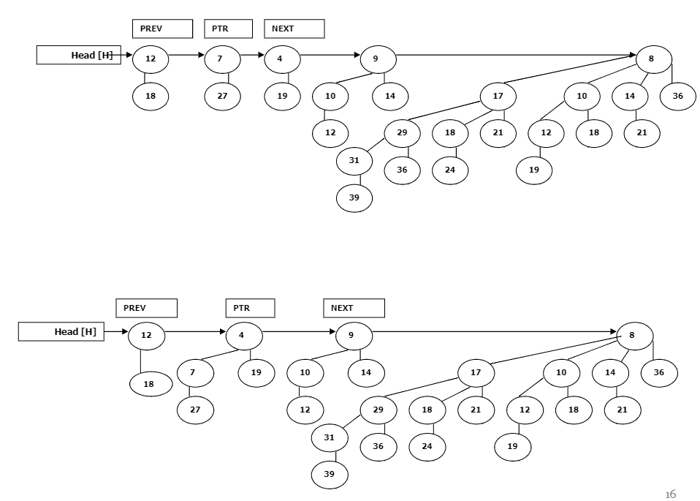

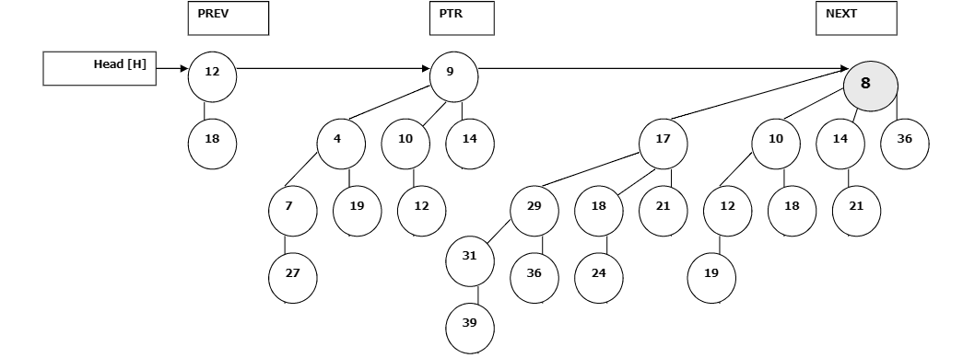

**Binomial Heap insertion**

Insert – insert key value x into binomial heap H

Algorithm:

1. Create a new binomial heap H1 of one node of value x
2. Unite H1 and H

**Delete-min / extract-min**

Delete-min is to delete the node with minimum key from binomial heap H

Algorithm:

1. Call find-min to find min node x of H
2. Remove x from root list of H
3. Create a new binomial heap H1 by delete x and reverse its children
4. Unite H and H1

Time: O(log n) Space: O(n)

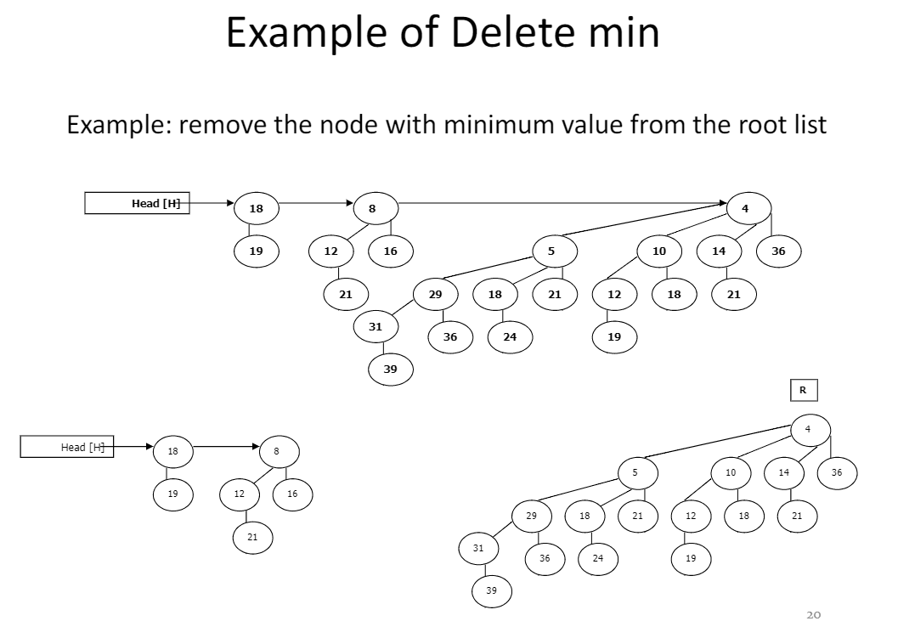

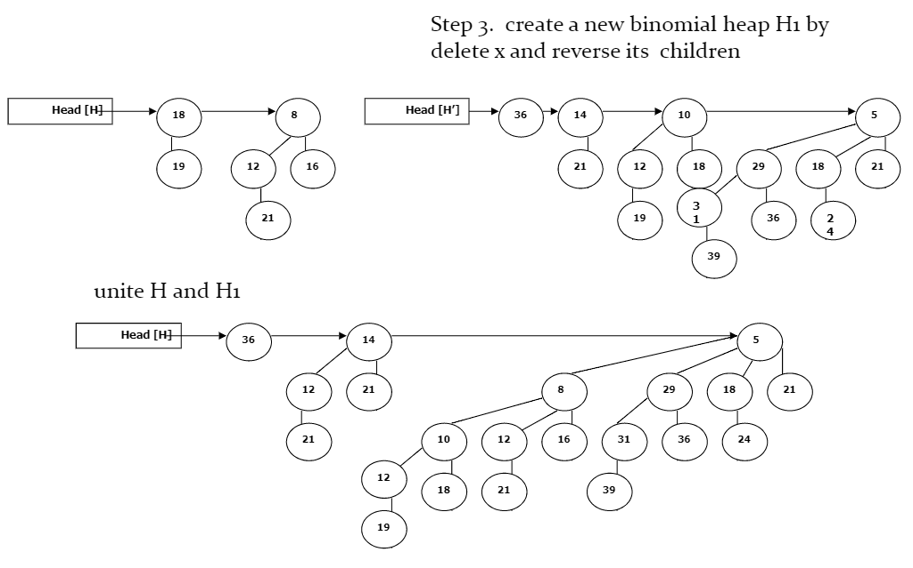

**Decreasing a value of a node**

Algorithm:

1. Decrease the key value of node x to new value k
2. If k is bigger than the current key value of node x, stop. Else set the key value of x to k, then heapify at x to make the resulted tree heap

Time: O(log n), because the maximum depth of node x is O(log n) and each tree node has pointer pointing to its parent node.

Space: O(1)

**Deleting a node**

Algorithm:

1. Decrease the key value of the node to -INFINITY
2. Call delete min

Time: O(log n), Space: O(1)

